SCHOOL OF ARCHITECTURE, COMPUTING AND ENGINEERING
Submission instructions:
- All pages to be numbered sequentially.
- Dissertation documentation to be navy blue color Hardbound (1 copy).
- Computer discs to be attached to the work in an envelope or purpose made sleeve adhered to the rear.
Module code | CN7000
Module title | Project Dissertation
Module leader | Mohamed Ismail Z
Supervisors | Ismail, Joshua, Sangeetha, Noris, Sudhasini
Assessment | A professional document of 15,000 words maximum (exclusive of appendices)
Weighting | 100%
Learning outcomes assessed by this assignment | - Demonstrate detailed knowledge of one chosen and highly specific area within the domain of their programme of study and communicate this knowledge through both a written report and an oral assessment.  - Demonstrate knowledge of research methods appropriate for Masters level research and to communicate this knowledge through both a written report and an oral assessment.  - Use analytic skills in assessing the works of others to assimilate these iteratively into an integrated framework of understanding.  - Critically reflect on the ethical, legal, and social considerations of a chosen project topic.  - Write a dissertation report, which contains a practical element of at least 25%, but not exceeding 50%, of the work.  - Manage and deliver the production of an extended piece of work according to the submitted plan, whilst liaising with a supervisor.  - Gather relevant information and data for the purposes of research  - Construct and implement a realistic research timetable  - Specify, design and implement a solution to a computer science related problem.  - Plan the production of an extended piece of work with defined fixed delivery date.  - Manage and deliver the production of an extended piece of work according to the submitted plan, whilst liaising with a supervisor.

CN7000 - MSc Dissertation

INTRODUCTION

This is a mandatory module for MSc-Business Information Systems Programme.

1. Aims
The MSc dissertation module is a piece of research work of 60 credits and is undertaken individually on a topic related to the field that the student is studying. The dissertation should be related to the taught element of the programme and/or the student's experience and interests. Students are given some flexibility in choosing a topic and are encouraged to think about it early and to discuss their ideas with potential supervisors and the module leader.
This module aims to develop a student’s research skills through one-to-one supervision to a sufficient standard so that the student produces a dissertation of potentially publishable quality.
This module will be delivered through a combination of some research methods lectures, chat-rooms and individual tutorials.

2. Research Methods Lectures
The research methods lectures are designed to give the student an understanding of what is required of them in terms of output; the timetable, terminology of research; analysing data; plagiarism; referencing; structuring, planning and management of a project; polishing the work and the viva.

2.1. Research Methods and Dissertation Writing Skills
The postgraduate students prepare a research proposal after the research methods workshop. This proposal will set out in detail the work that will be carried out for the dissertation.
The research proposal must set out the problem and the methodology to be adopted and be a feasible project for the time available.
Where a student is following a specialised track, they must focus their proposal and dissertation on that specialisation and choose a related topic for their research proposal and develop this for their dissertation.

2.2 The Research Methods Workshop

The research methods (RM) workshops will be conducted over a three weeks period at the start of the dissertation semester and will cover the following topics.

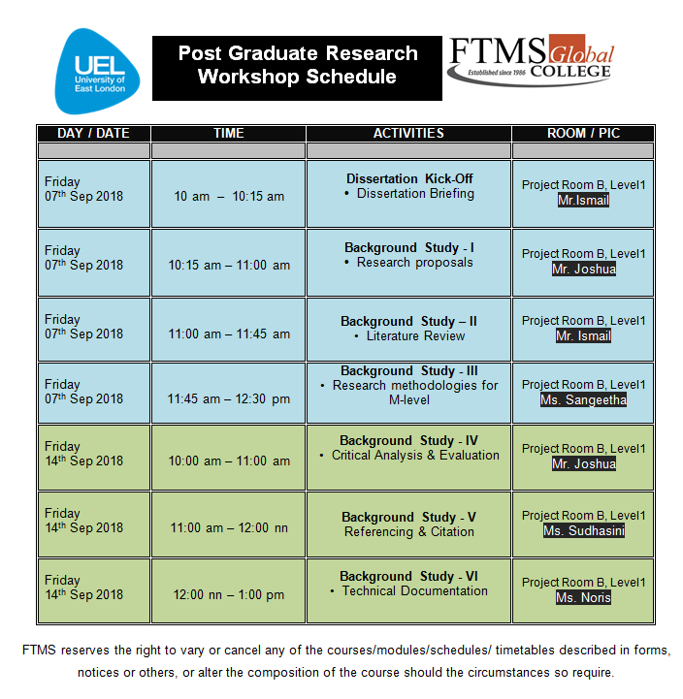

3. Tutorial Sessions

The supervisor's role is to give guidance to the student as to the direction of the dissertation. The student can expect help with such things as referencing and structuring of the work etc. In addition, draft work (e.g. a chapter) is normally commented on by the supervisor at the tutorial. However, the work is very much the student's and so the student cannot expect direct help with content. Neither can the student expect the supervisor to ‘mark’ interim work as it appears.

3.1 Dissertation Student – Supervisor contact

The purpose of the contact is to give students the support they need to enable them to complete an acceptable dissertation within the timescale allowed.
It is the responsibility of the student to contact their supervisor to discuss their research and ensure that their work progresses according to the plan that they had prepared in their research proposal.
Regular contact of a minimum of 10 hours between the student-supervisor is a requirement of the programme and a pre-requisite for submission of the dissertation.

4. Assessment

The assessment for this module will be based upon the written report providing evidence of theoretical understanding and demonstrating practical work (including relevant information), which will be assessed both orally (30 Minutes) and as text by two markers (max. 15000 words). In accordance with the framework, students MUST obtain a minimum of 50% overall in order to pass this module.
The dissertation element (including oral assessment) is worth 100% for this module and consists of one individual piece of work. One hard copy of the dissertation is to be handed into Graduate School Office Counter, Level 1.

Dissertation completion schedule
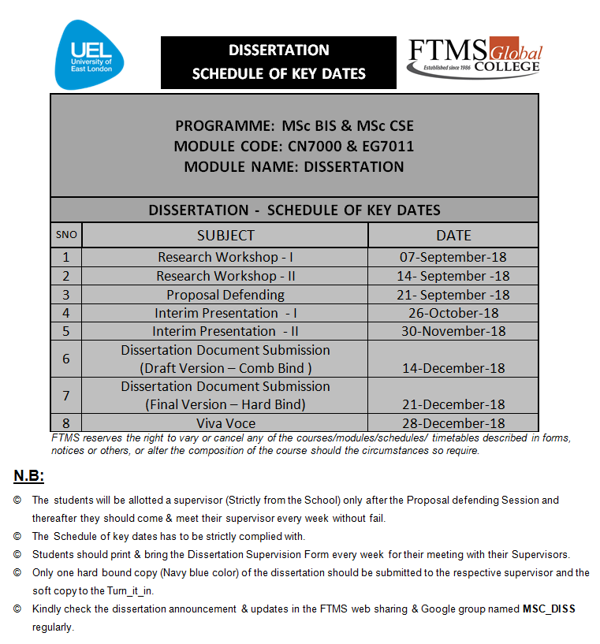

4.1. Oral Examination

The oral examination takes place following the handing in of a hard copy of the dissertation.

5. Dissertation Moderation

Once the student has submitted their dissertation, the module leader will distribute it to the first supervisor and select the assessor based on the dissertation title and assessor's expertise.
Upon the completion of the marking, all marks are returned to the module leader. Any marks of more than 10% difference will go to the project team for third marking. The project team mark is the final mark.

6. Health and Safety

It is our policy to do all that is reasonably practicable to ensure the health, safety and welfare of all students, as well as people who may visit any of our premises. As such we comply with all relevant health and safety legislative requirements.
On the programme we will provide safe systems for working, a safe environment for teaching and learning, adequate health and welfare arrangements and facilities, and the elimination of risks associated with health and safety.

APPENDIX

Appendix A…………………………………..…... Cover Sheet Format
Appendix B…………………………………..…... Dissertation Certificate
Appendix C…………………………………..…... Assessment Form
Appendix D…………………………………..……Supervision Form

Appendix A

<TITLE OF THE DISSERTATION>

A dissertation submitted to the
School of Architecture, Computing and Engineering (ACE),
UNIVERSITY OF EAST LONDON
in partial fulfilment of the requirements for the award of the degree of
Master of Science
in
Business Information Systems
by
<Name of the student>
<Register Number>
submitted on
<Date>
Guided by
<Supervisor Name>

School of Engineering & Computing Sciences
(SOECS)
FTMS COLLEGE
CYBERJAYA – 63000
December 2018

FTMS COLLEGE
School of Engineering & Computing Sciences
(SOECS)
This is to certify that this dissertation work entitled

<TITLE OF THE DISSERTATION>
is a bonafide record of the work done
by
<Name of the student>
<Register Number>

at FTMS College, Malaysia during the year 2018-2019 in partial fulfilment of the requirements for the award of the degree of
M. Sc. Business Information Systems

<Supervisor Name>
<Designation>

Submitted for the University of East London and the Presentation and Viva held at FTMS College, Cyberjaya, Malaysia on _________________.

Appendix B

(Certificate from the Internal Guide)

Guide Name
Designation
FTMS College
Cyberjaya, Malaysia.

CERTIFICATE

This is to certify that this dissertation entitled “ <Title of the dissertation>“ submitted in partial fulfilment of the requirements for the award of the degree of M.Sc. Business Information Systems to the University of East London, UK through FTMS College, Kuala Lumpur, Malaysia is a bonafide record of the work done by <Name of the student> (Reg.No. ) under my supervision and guidance.

Date : Signature of the Guide

Appendix C
MSc BIS Dissertation Report (25% Practical)
Student Name:------------------------- Student Number:-------------------------------
Course :------------------------- Date : December 2018
TITLE:------------------------- -----------------------------------------------------------------------
Marker: (1st /2nd)**--------------------------------------------(** Delete as Appropriate)
Item % of Total Actual Mark
- Use of existing Theory 20%
Markers to type over!! Variety, existence, focus, relevance and
understanding shown of the references.
- Analytic quality of Report 25%
Markers to type over!! Made use references by developing something
from them? How coherent, clear and sensible are the arguments and how
consistent (in tone, ambition and interpretation) is the work? Appropriate
representation of thinking (e.g. graphs, drawings etc.).

- Implementation/Practical Aspect | 25%
Markers to type over!! Quality of the student’s
practical. Complimentary/Relevant to theory? Difficulty of task
undertaken? Any particularly subtle approaches? Ability shown
in writing up this practical part. Is it clear what the student
(as opposed to others) has ‘done’.

- Critical Evaluation/  Conclusions | 15%
Markers to type over!! Is there a justified methodology/approach?
Does what the student claims to have done both in the interpretation
of theory and the practical hold up to scrutiny? Do the Conclusions
match the rest of report? Do data records (e.g. diary) to aid
evaluation exist and has the student commented on both
the process and the product of their work?

(v) Presentation  Markers to type over!! Flow, look, typos, formatting  (vi) Oral Assessment 10%  Markers to type over!! Did they respond clearly and demonstrate relevant and supportive statements of their dissertation. | 5%
TOTAL MARK _____________ Marker Signature ________
MSc BIS Dissertation Report (50% Practical)
Student Name:------------------------- Student Number:-------------------------------
Course :------------------------- Date : December 2018
TITLE:------------------------- -----------------------------------------------------------------------
Marker: (1st /2nd)**--------------------------------------------(** Delete as Appropriate)
Item % of Total Actual Mark
- Use of existing Theory 15%
Markers to type over!! Variety, existence, focus, relevance and
understanding shown of the references.

- Analytic quality of Report 20%
Markers to type over!! Made use references by developing something
from them? How coherent, clear and sensible are the arguments and how
consistent (in tone, ambition and interpretation) is the work? Appropriate
representation of thinking (e.g. graphs, drawings etc.).

- Implementation/Practical Aspect | 45%
Markers to type over!! Quality of the student’s
practical. Complimentary/Relevant to theory? Difficulty of task
undertaken? Any particularly subtle approaches? Ability shown
in writing up this practical part. Is it clear what the student
(as opposed to others) has ‘done’.

- Critical Evaluation/  Conclusions | 8%
Markers to type over!! Is there a justified methodology/approach?
Does what the student claims to have done both in the interpretation
of theory and the practical hold up to scrutiny? Do the Conclusions
match the rest of report? Do data records (e.g. diary) to aid
evaluation exist and has the student commented on both
the process and the product of their work?

(v) Presentation  Markers to type over!! Flow, look, typos, formatting  (vi) Oral Assessment 10%  Markers to type over!! Did they respond clearly and demonstrate relevant and supportive statements of their dissertation. | 2%
TOTAL MARK _____________ Marker Signature ________
Appendix D
